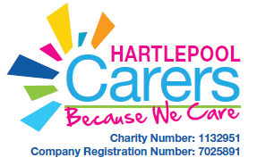
Box Clever Shopping List
Remember sticking to your shopping list will help to save money

FOOD ITEM | HOW MANY | COST | SHOP

