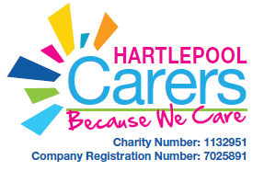
Box clever
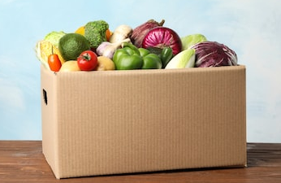

What is Box clever?

Box clever is a programme to help Families improve their cooking, shopping and budgeting skills.

Why are we delivering this programme?

Since the outbreak of Covid 19 many Families finances have changed. People have been furloughed, changed jobs or have found themselves unemployed. The impact on Family finances could be long term. We would like to address the issue and look at changes we can all try, to make the money we have in our pocket go that bit further.

What do we aim to achieve?

Our vision is to create a community of savvy shoppers who can use minimal budgets to provide healthy nutritious meals.

We want our Carers to share tips and offer advice on the ways they find to save money throughout the home and to take part in an online forum to enable Carers to share any new ideas or information.

Looking to the Future

After lockdown restrictions have ended and we can relax social distancing, we would like to meet on a regular basis to swap tips, share advice and have a cuppa.

Our vision is to engage with a local allotment scheme so those who would like to get their hands dirty can have a go at growing their own produce.

One thing that was identified early into lockdown was how important Tech products were to enable people to keep in touch and informed. We will be adding Box clever workshops to our website and you tube channel.

With this in mind, Hartlepool Carers have a Tech loan service and are able to loan tablets and laptops to Carers allowing them to access the project material online.

Making the most of what we get

Many of our carers will be aware we have access to unsold food that is donated to us by various organisations across Hartlepool. The ingredients which we receive can be close to their use by date and can often be a random collection of ingredients. We want to be able to look at what we have and make the produce into some great Family meals. Sharing recipes and ideas will hopefully help us to become more innovative with the ingredients we have to hand.

How to eat healthy and save money

When Money is tight, it can be daunting to think about providing your Family with healthy meals. But with careful menu planning and careful shopping it can be done.
Some simple food swaps can mean a healthy diet is still within reach and within budget. A healthy diet means getting a good balance of all the food groups, plenty of fruit and vegetables, and watching the salt, sugar and fat.
Learning some basic cooking skills and adding some easy recipes to your repertoire can make providing healthy meals for your family a little easier.

Menu planning and shopping
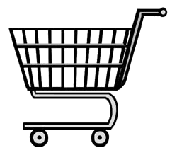
Shopping every day can be expensive, as food can go to waste. Planning your shop in advance and making the most of leftovers can help your budget go further.
Use the enclosed menu plan to help you get the most out of your ingredients.
When choosing meals consider the following-

- Think about using leftovers to cook other meals.
- Buying ingredients in bulk can often be cheaper. Think about how you can use the same ingredient to produce two different meals.
- Before you plan your menu and go shopping the most important thing to do is to look in your fridge and freezer, make the most of ingredients you already have.
- Make a shopping list and stick to it, do not be tempted to offers you do not really need.
- Try shopping a brand below the one you usually buy; chances are you will not notice the difference.
- Try Supermarket own brands, they are often a lot cheaper that branded goods.

If you can save money on every item, you normally buy this can add up at the till.

Frozen food and batch freezing

Keeping a supply of fruit and vegetables in the freezer is a great way to get your 5-a-day. They tend to be cheaper than fresh, and because you use what you need, nothing is wasted.
Adding fresh or frozen vegetables to your meat-based meals not only helps you get lots of fibre, vitamins and minerals - but your food will go further, saving more money.
If you cook in batches, you can use reusable dishes or freezer bags to freeze extra portions to use later, saving time and money.
Spot some bargain food and the Supermarket such as Fruit and Vegetables- save money by freezing at home yourself.
Buy larger portions of meat, which can be cheaper when you buy in bulk and split it down into portions to put in the freezer.

Using your leftovers to create new dishes.
Most leftovers can be used the next day.
- Chicken or meat- use the leftover meat to make soup or add to stir fry’s
- Boiling meat bones or chicken carcass will give you some great stock.
- Stale bread - blitz or grate to use as breadcrumbs to cover dishes like cauliflower cheese or use in homemade burgers.
- Cooked Vegetables- Try adding to Frittatas, quiche, curries or soups.
- If food is coming to the end of its use by date and you know you are not going to use it. Check it can be frozen and pop it in your freezer. This will extend its shelf life and save food waste.

Fuel economy
Many Families struggle with the increasing cost of Fuel. Cooking can use up a lot of energy and in turn money. Think about what foods can be cooked together to save energy. Cook all meals in the oven at the same time, casseroles, potatoes, baked goods.
Ensure you are on the best energy plan to get best value for money. People will often stay with the same energy provider but could save by switching.
Look online to view comparison sites or check you are on the cheapest tariff with your chosen provider.

