Box Clever Recipes

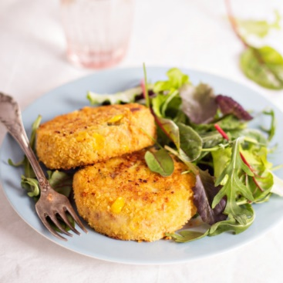
Store cupboard Tuna Fishcakes

Ingredients
2 tins Tuna
4 large potatoes
2 Tablespoons Mayonnaise
1 small can sweetcorn
2 eggs
1 chilli finely chopped
1 Clove Garlic finely chopped
1 Onion finely chopped
Juice from 1 lemon
100g breadcrumbs (Grate sliced bread)

How to make

- Boil the potatoes, mash and season with salt and pepper. Allow to cool.
- Add the Tuna, Mayonnaise and sweetcorn to the cooled potatoes.
- Lightly fry the onion, chilli and garlic and add to the tuna and potato mix. Squeeze in the juice from one lemon.
- Grate or blend the sliced bread to form breadcrumbs.
- Place some flour onto a small plate, whisk the eggs into a bowl and put the breadcrumbs into a shallow dish. Place the ingredients side by side.
- Divide your Potato and fish mixture into 4. Take your first Pattie shape it and cover it in flour. Next coat in the whisked egg and finally into the breadcrumbs. (It is important to do it in this order to ensure the breadcrumbs stick to the Pattie) Repeat with the other patties.
- Chill until needed.
- Shallow fry on a low to medium heat until golden brown. Place in the oven to warm through. Serve with vegetables or salad.

Adaptions- You can alter this recipe to use ingredients you already have in your cupboard or freezer. Replace the Tuna with Salmon or any frozen fish, you could also use corned beef or cheese in place of the fish. Leave out the sweetcorn and replace it with spring onions.

Baked Sweet potatoes with homemade slaw
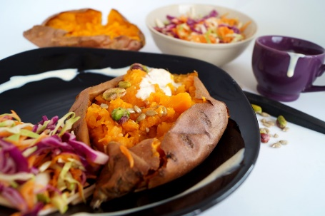
Ingredients

4 sweet potatoes
White or red cabbage
Carrots
Onion
Mayonnaise

How to make

- Wash the sweet potatoes and prick several times with a fork.
- Cook in a moderate oven until the potato feels soft when inserting a knife.
- Finely shred the cabbage and wash under running water, finely chop the onion and grate the carrots. Add all ingredients into a large bowl.
- Add the mayonnaise until all the ingredients are covered.
- Serve with the sweet potatoes.

Adaptions- Use different veg for the slaw. Use white potatoes instead of sweet. Serve with salad or meat.

Store cupboard Vegetable pasta bake

Ingredients

Pasta (any variety)
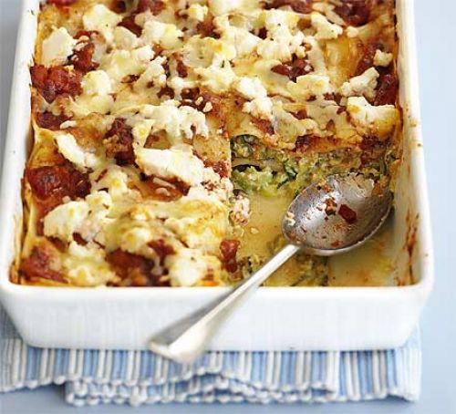
Ready-made pasta sauce (any variety)
Selection of the following vegetables-
Peppers
Sweetcorn
Onions
Mushrooms
Broccoli
Cauliflower
Green beans
Courgettes
Grated Cheese and breadcrumbs

How to make

Remember that with this dish you can use up all your leftover veg. It does not matter which vegetables you have; just choose a selection you have to hand.

- Cook your pasta according to the packet.
- Cook all your vegetables, lightly fry in some oil, boil or roast in the oven. Cutting them into bite size pieces will shorten the cooking time.
- In a large dish empty your chosen pasta sauce, this could be Tomato based or creamy. You can use a jar of ready-made sauce, a packet, or make your own.
- Add all your cooked Vegetables and pasta to the sauce. Cover with breadcrumbs and cheese and bake in a moderate oven for 25mins.

Adaptions- Use any pasta you have in the cupboard, try wholemeal as a healthier option. Use additional cheese in the sauce to add more flavour. Add chicken or fish to make the dish more filling. Use herbs to flavour and add interest.
The most important thing is there are no rules, add ingredients you have and enjoy, leave out the things you don’t.

Too Easy? Why not make your own Bechamel sauce instead of using a ready -made?

Bechamel/white sauce
Ingredients

60g butter
60g plain flour
600ml Warm milk
Salt and freshly ground black pepper, to taste

How to make
- Melt the butter in a saucepan over a low heat.
- Add the flour and cook for 2 mins, stirring all the time. The mixture will look like a paste.
- Gradually add the warm milk stirring all the time until you have a thick sauce.

This sauce can be used for many dishes just flavour it in any way you like, add cheese, parsley, cream or herbs.

Kids Pitta Pizza

Ingredients

Pack Pitta breads
Tomato sauce (Ready-made or homemade)
150g Cheese

Selection of toppings
Onions
Peppers
Tomatoes
Sweetcorn
Mushrooms

How to make

- Lay out the pitta breads on a baking tray.
- Prepare any vegetable you are using into thin slices (the pittas won’t be in the oven for long so the thinner the better, so they cook quickly)
- Spread the top of the pitta bread with the tomato sauce of your choice.
- Add a selection of toppings and sprinkle over grated cheese.
- Cook in a moderate oven until golden and the cheeses has melted.

Variations- The pittas can be changed to any sort of bread try Naan, paninis or French stick. Add pepperoni, bacon or left- over meats to make the meal more filling.

Need more of a challenge? Why not make your own easy flatbread dough?

Flatbread dough
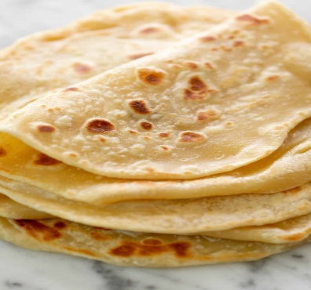
Ingredients

- 300g plain flour
- 1/2 tsp salt
- 50g butter
- 185 ml milk
- 1/2 tbsp oil (for cooking)

How to make

- Melt the butter and milk together in the microwave or on the stove,
- Add the mixture to the flour and mix to form a dough.
- Knead for 2 minutes then allow to rest for 20 mins.
- Dust the worksurface with flour, spilt the dough into 4. Roll out each piece to around 0.5cm thick.
- Take a frying pan and lightly oil the full surface. Wipe off any excess with kitchen roll. Heat the pan over a moderate heat and add your first flatbread. Turn over when it begins to bubble. Cook the others in the same way. Ensure you wipe the pan after each bread to stop smoking.
Use for pizza bases or to serve with curry or soup.

Potato and Leek soup

Ingredients

- 3 large leeks
- 2 cloves garlic crushed
- 2 tablespoons butter
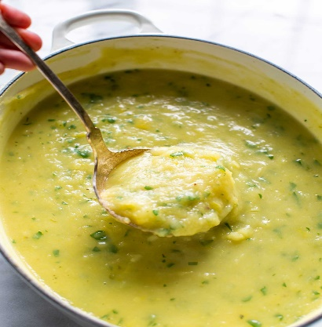
- 2 stock cubes made up with 1 pint of boiling water
- ½ pint milk
- 2 pounds potatoes peeled, diced into 1/2-inch pieces
- 1 teaspoon salt
- White or black pepper to taste

Optional
- 150ml cream
- Chives or croutons

How to make

- Clean and cut the leeks- take off both ends of the leek. Spilt lengthways. Run water down the leek to remove any mud or grit. Slice into 2 cm slices.
- Cook the leeks and crushed garlic in butter until soft.
- If you want a thicker soup add 1-2 tablespoon of flour, Cook for 1 minute.
- Slowly add the made-up stock and milk, add the potatoes, salt and pepper
- Simmer for 30 mins or until potatoes are cooked. Season with salt and pepper.
- At this stage you can blend the soup or leave it as it is.
- Optional- add cream just before serving. Sprinkle with chives or croutons (optional)

Alternatives- Use up you left over chicken, add different herbs or garlic.

