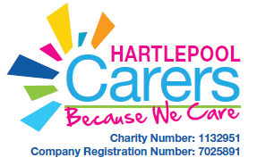

BOX CLEVER

Hartlepool Carers are pleased to introduce you to Box clever. You will find a box of low cost, store cupboard ingredients with recipes on how to turn them into quick, easy to make Family meals.
There is also some useful information on how to budget and tips on how to save money, as well as some basic online workshops that offer more information and advice.
This is just the beginning- we would like you to share your money saving tips and recipes with other carers on our Facebook pages.

https://www.facebook.com/hpoolcarers/

Post your photos of the recipes you cook with ideas on how to improve them.
We will post a Recipe of the week and money saving tips.

We look forward to your posts!

Team at Hartlepool Carers

